Theme Week – P.E. Group

Curriculum activity

Twenty minute activity with ten children split into two groups of five and carousel with each activity. The activities have been produced to link to the theme of the Commonwealth Games and taking into account the National Curriculum for Physical Education which is appended for reference.
There will be a demonstration for each activity and all scores entered into a league table.

There are four activities:

- Swimming
- Relay
- Target throw
- Standing long jump

The activities were arranged in the hall as below:
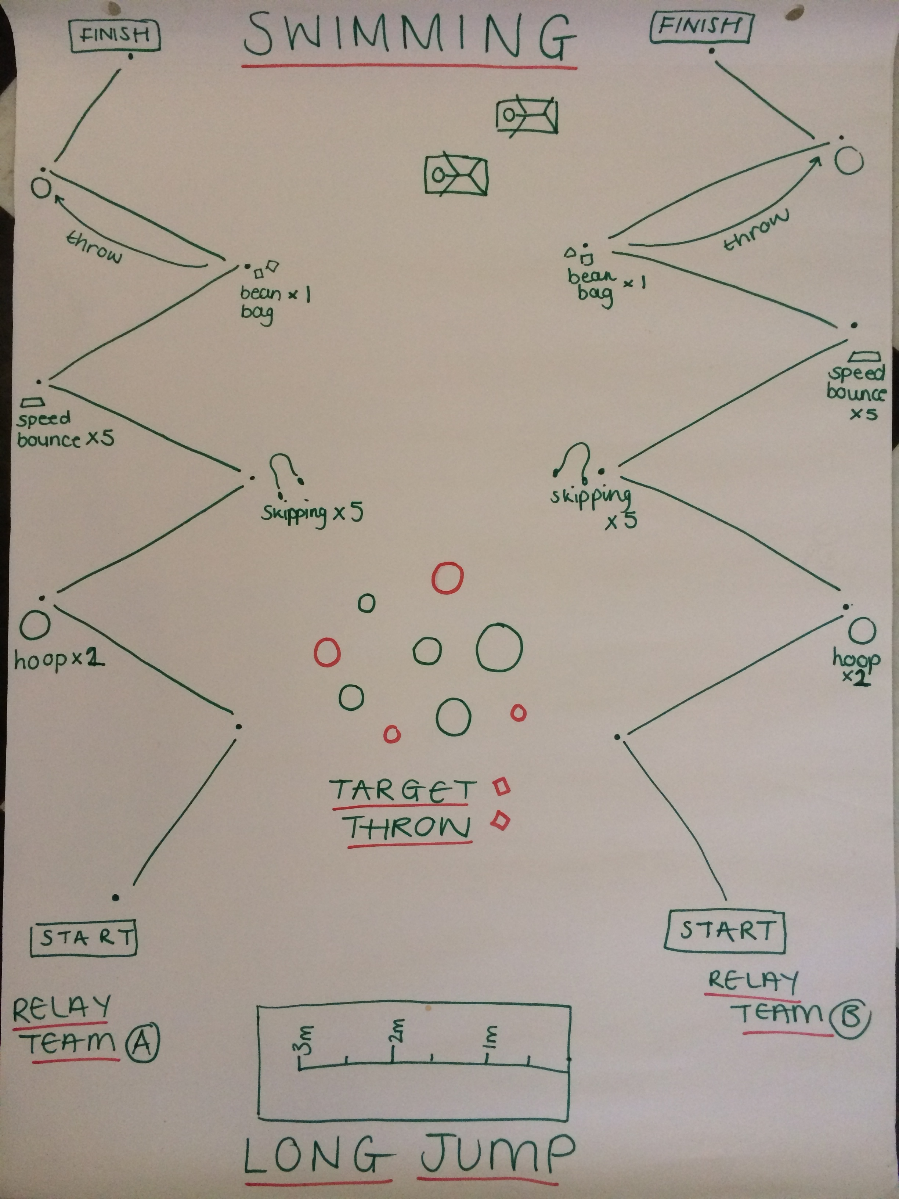

The activities were organised as follows:

1. Swimming – split into two groups of five children, sliding on the floor mats. If the child is not strong enough, team member to push. This is timed against one another. The fastest group gets the most points.

2. Relay – split into two groups of five children, bot relays happening at the same time, either side of the room, timed against one another. The relay involves, hopping, speed bounce, side step, hoop, running, skipping and throwing. Complete multiple times to record the fastest (time permitting). The fastest group gets the most points.

3. Target throw – Children throw bean bags into hoops in a 3 by 3 array with different points (2, 3 and 5) for different coloured hoops. One larger hoop at some distance from the array with a larger score (e.g. 25). Multiplier hoops of x 2 and x3 at greater distance. Group points.

4. Standing long jump – Each team total distance added up, points allocated for each group. Each child has multiple attempts and the furthest distance counts to the total.

All points allocated as a group, 12 groups = 12 countries from the commonwealth chosen out of a hat (or other suitable vessel).

Lunchtime Activity

10 minute activity for 60 children, based on Wake Up and Shake Up which allows children to become physically confident in a way which supports their health and fitness. The 2014 National Curriculum aims for children to be taught to perform dances using a range of movement patterns, develop flexibility, technique, control and balance which this sessions accomplishes. The session includes a warm up, activity and cool down

Warm up – Avicii, Wake me Up http://www.youtube.com/watch?v=IcrbM1l_BoI (use for audio not visual)

Jogging on the spot
Fast running on the spot
1 – Touch ground with right hand
2- Touch ground with left hand
3- Straight jump up
4 – 2 star jumps
When instructor calls out the number you carry out the instruction
Stretches – lunges forwards, arm stretches, side stretches, hula hoop stretches

Wake up Shake up Routine – Timber - Pitbull and Keisha, Instrumental with Hook (http://www.youtube.com/watch?v=5_pqkkYlrtU&feature=youtu.be)

March x 16
Right step and clap - Left step and clap x 16
Forward heel – back toe x 16
High skips x 8
Lasso x 8
High skips x 16
Grapevine right – jump – grapevine left – jump x16
Forward step – hat off – backwards step – jump x 16
Repeat from start

Cool down – Enya, Only Time (http://www.youtube.com/watch?v=7wfYIMyS_dI)

Spread out in hall, close eyes, head down
Deep breathing in and out for counts of 8
Slow roll down to floor – head, neck, shoulders, waist, knees, ankles
Sit cross legged on floor, eyes closed, head down
Deep breathing in and out for counts of 8 – listen to the music
Slowly stand up and shake out

National Curriculum – Physical Education

Purpose of study

A high-quality physical education curriculum inspires all pupils to succeed and excel in competitive sport and other physically-demanding activities. It should provide opportunities for pupils to become physically confident in a way which supports their health and fitness. Opportunities to compete in sport and other activities build character and help to embed values such as fairness and respect.

Aims

The national curriculum for physical education aims to ensure that all pupils:
- develop competence to excel in a broad range of physical activities
- are physically active for sustained periods of time
- engage in competitive sports and activities
- lead healthy, active lives.

Attainment targets

By the end of each key stage, pupils are expected to know, apply and understand the matters, skills and processes specified in the relevant programme of study.

Schools are not required by law to teach the example content in [square brackets].

Subject content

Key stage 1

Pupils should develop fundamental movement skills, become increasingly competent and confident and access a broad range of opportunities to extend their agility, balance and coordination, individually and with others. They should be able to engage in competitive (both against self and against others) and co-operative physical activities, in a range of increasingly challenging situations.

Pupils should be taught to:

- master basic movements including running, jumping, throwing and catching, as well as developing balance, agility and co-ordination, and begin to apply these in a range of activities

- participate in team games, developing simple tactics for attacking and defending

- perform dances using simple movement patterns.

Key stage 2

Pupils should continue to apply and develop a broader range of skills, learning how to use them in different ways and to link them to make actions and sequences of movement. They should enjoy communicating, collaborating and competing with each other. They should develop an understanding of how to improve in different physical activities and sports and learn how to evaluate and recognise their own success.
Pupils should be taught to:

- use running, jumping, throwing and catching in isolation and in combination

- play competitive games, modified where appropriate [for example, badminton, basketball, cricket, football, hockey, netball, rounders and tennis], and apply basic principles suitable for attacking and defending
- develop flexibility, strength, technique, control and balance [for example, through athletics and gymnastics]

- perform dances using a range of movement patterns

- take part in outdoor and adventurous activity challenges both individually and within a team

- compare their performances with previous ones and demonstrate improvement to achieve their personal best.

Swimming and water safety

All schools must provide swimming instruction either in key stage 1 or key stage 2.

In particular, pupils should be taught to:

- swim competently, confidently and proficiently over a distance of at least 25 metres

- use a range of strokes effectively [for example, front crawl, backstroke and breaststroke]

- perform safe self-rescue in different water-based situations.

