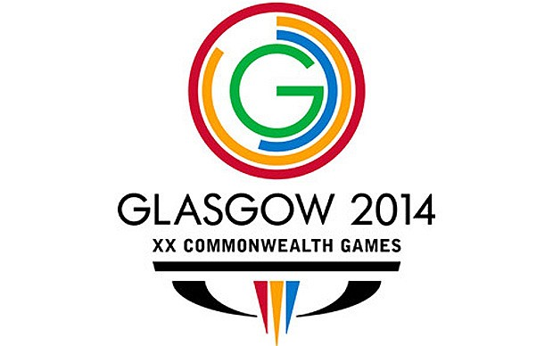
Music Resource Pack
Activities
Quiz
As a hook into the commonwealth games topic, you could use a commonwealth games show!
The children can answer questions about music from countries in the commonwealth, guessing which country the tune or instrument comes from. This will help to expand their knowledge and understanding of different cultures and their associated instruments and music style, giving them a chance to compare music from countries around the world!
Another round to the quiz could be interpreting sport through music. The teacher could perform a beat and the children could guess what sport it represents, for example, the long jump on the drums has several fast beats, a pause and then a single louder beat.

Composition using instruments
Following on from the quiz, children could create their own interpretation of sports using a range of instruments. Sports could include synchronised swimming, long jump, high jump, 100 meter sprint, boxing, and hurdles.
For group work and cross curricular links, children could also act out the sporting activities and write a diary entry for a sportsperson.
Children could also compose their own short piece of music in the style of a commonwealth country.
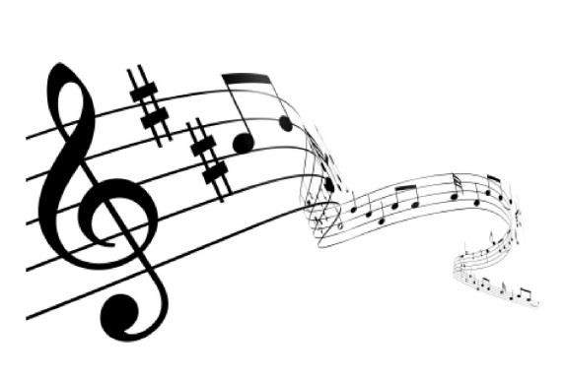

Performance
When the compositions are complete, children could perform their musical masterpieces to the rest of the class.
To further develop their geographical knowledge, the children could learn about flags from the different countries. They could then use the flags to vote for the country that they think the music comes from.

Instruments
To provide practical, hands on experiences, the children could have the opportunity to play instruments from different countries (if these are available).

Art and Design Technology
Children could research different countries, and reproduce flags from these countries. They could then create their own string instruments using boxes, straws, wood strings and wires.
Using the amazing, creative resources made by the children, you could create an interactive display. This could include images or video clips from their performances.

Make own country
Once the children have gained an understanding of the commonwealth games, as a culmination of all of the above activities, they could design and create their own country to compete in the games. This could include creating their countries own flag, competing sport and national anthem.

Commonwealth games
Using the countries, sports and national anthems created by the children, you could have a day of commonwealth activities created by the children. The children could be assigned different roles within their countries, for example, athletes, musicians, design team, and production management.
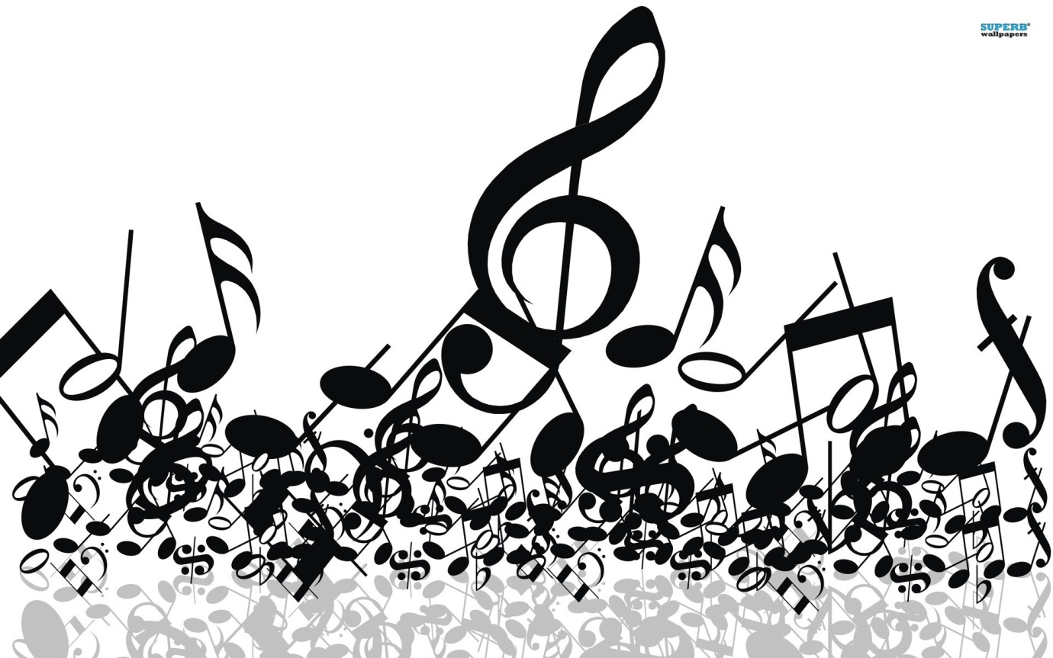
This could be a whole school activity, as an assembly or with each class as a different country.

