Commonwealth Games – Maths Activities

Introduction:
To celebrate the Commonwealth Games in Glasgow this year, we have designed a short series of themed maths activities around this topic.
The focus of these activities is to develop problem solving skills for pupils in years 3 and 4, in addition to data handling. The activities are designed to include a number of learning styles and are accessible for pupils at all levels. Each activity is currently planned to take 10-15 minutes. However, all of the activities in this pack can easily be extended and this pack includes a variety of extension activities and questions. There are also cross curricular links to geography and P.E. within these activities.
Links to the New National Curriculum:
The national curriculum for mathematics aims to ensure that all pupils:
- Become fluent in the fundamentals of mathematics, including through varied and frequent practice with increasingly complex problems over time, so that pupils develop conceptual understanding and the ability to recall and apply knowledge rapidly and accurately.
- reason mathematically by following a line of enquiry, conjecturing relationships and generalisations, and developing an argument, justification or proof using mathematical language
can solve problems by applying their mathematics to a variety of routine and non-routine problems with increasing sophistication, including breaking down problems into a series of simpler steps and persevering in seeking solutions

Year 3: Children understand how to do division with remainders
Recall and use division facts for tables 2, 3, 4, 5 and 8.
Solve problems involving division
Use mental methods of simple division.

Year 4: Recall and use division facts up to 12 x 12.
Solve addition and subtraction and multi-step problems in contexts deciding which operations and methods to use and why.
Use place value, known and derived facts to multiply and divide mentally
Approaching problem solving in a systematic way, observing patterns and applying logic to produce the desired outcome (Activity 1 - working out that the room with the highest number of beds will fill the hotel and be most profitable for the hotel.)
Pupils solve simple problems in contexts, deciding which of the four operations to use and why. These include sharing problems such as 12 sweets shared equally between 4 children; 4 cakes shared equally between 8 children).

Activity 1 – ‘The Hotel Organiser’
Curriculum links:
This activity is designed to develop problem solving skills making use of basic division. This activity also promotes collaborative learning through the high level of team work required in order to get the job done! The challenge also calls for speaking and listening, linking it well literacy. The activity can be differentiated to suit different year groups in key stage 2, SEN and G&T pupils.
Resources:
- List of athletes/pictures of athletes
- Bedroom pictures (3, 4, 5 and 6 beds)
- Hotel (optional)
- Criteria for organising athletes
- Smart dress and Headset (optional)
- Blu-tac
Instructions:
- Introduce pupils to ‘The Clyde Thistle Hotel’ at the Commonwealth Village in Glasgow. Explain to the pupils that the Hotel Booking Organiser has left and that you need their help to organise where the athletes will stay. This is an emergency as some of them are due to arrive today! The best pupils may be appointed as the new Booking Organiser at the Hotel.
- Show the pupils a plan of the hotel which has a number of bedrooms. The number of beds in each room varies from 2 beds up to 6 beds (see resources attached).
- Present the pupils with a list/picture of all of the athletes who need to stay at the hotel and explain that they needed to be organised into rooms. (Attached to this document are 20 athletes, the number of athletes used in this activity can be changed according to the length of the activity and to suit different abilities.) The script we have used begins the activity with 8 athletes and then more arrive later (see resources for details).
- Ask the pupils to work together in groups to determine how to organise the athletes. Guide the pupils to develop a systematic approach to their organisation by explaining that the hotel wants no or the fewest spare beds in each room as possible. There is a script to use which has specific criteria and a set answer for some of the rooms some of the athletes’ positions (see resources).
- To make the activity more challenging additional criteria can be given to the pupils i.e. athlete x can’t share with more than 2 people.

Hook:
To provide a ‘hook’ into the activity, we have chosen to dress up as hoteliers and act out the operational management of the hotel to engage the pupils into a real-life scenario.

Activity 2 - ‘Marathon Map’

Area of maths:
- Problem-solving (reasoning and trial and improvement)
- Addition

Resources:
- Maps (A2 size paper)
- String
- Ruler
- Papers
- Pencils
- Blu-tac

The context of the task
- We have drawn a street map of Glasgow, including landmarks, for the marathon runners.
- We measured out two routes from point A to B (where the runners will be running).
- We then measured out the string that fits the route.
- The aim for the children is to work out how to get from A to B.
- In addition, the children have to try and collect points as possible by going past the most interesting landmarks for the enjoyment of the spectators.
- The more interesting landmarks get the children more points because they on a harder route.

Instructions:
- You are going to plan the route for the commonwealth marathon
- You have a street map of Glasgow
- The 26 miles of the marathon has been scaled-down to this length of string (hold up string)
- You need to find a 26 mile route for the marathon on the map
- When you are planning your route, you need to include as many landmarks as possible to make it interesting for spectators
- The more interesting the landmark the more point you get
- The aim is to get as many points as possible
- Place the string on the start point
- Every time you turn a corner blue-tac it down
- If you have extra string or not enough string at point B then you will have to go back and take an alternative route to reach point B again

Mathematical skills:
- This activity involves reasoning and trial and improvement because once the children have tried a route that doesn’t work, then they need to back track and try a different route that will work in order to get from A to B.
- Also, the children will have to reason about which landmarks they can and cannot go to as they cannot visit them all because the marathon will be too long (and they will run out of string).
- Furthermore, simple addition is being used to add up how many points the children have earnt by visiting landmarks.

Differentiation:
- This task can be made simpler for lower ability children by taking away the length of the string and asking them to independently find a route of any length and still visit as many landmarks as possible.
- This task can be made harder for higher ability children by introducing co-ordinates (i.e., visit the landmark in grid C4). Another way of making this task more challenging is to let the children start at any given point using the same length of string in order to visit more landmarks.
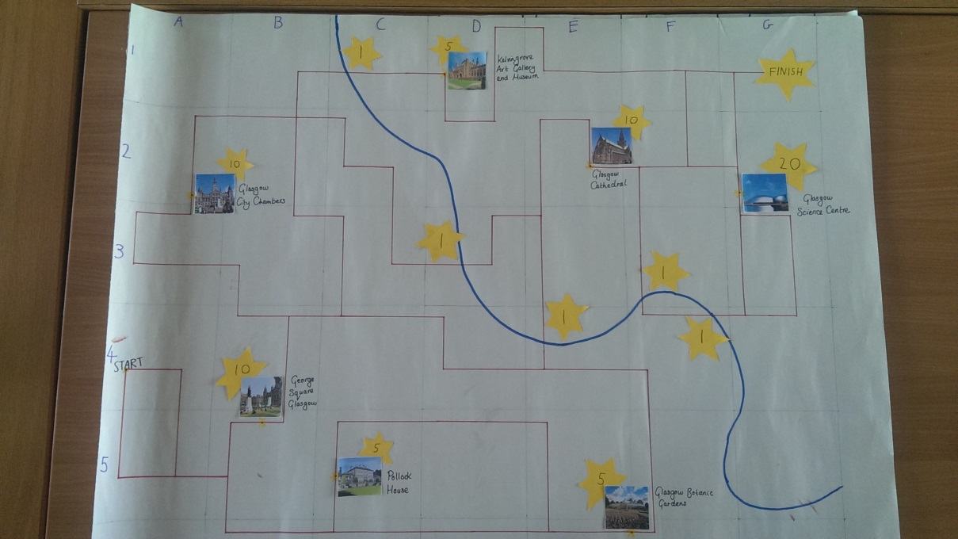

Activity 3 Commonwealth team ‘Burpee’

This activity focuses on children’s data handling skills. It teaches children to use simple data recording techniques as well as totalling and presenting this data in a bar chart. Different elements of the activity can be adapted to simplify or give additional challenge to children of different ability levels.
Instructions
- Introduce children to the new commonwealth activity team burpee. The new sport requires countries (small groups of children) to work in teams to record the highest number of burpees. Athletes participate one at a time with the rest of the team recording the score in a tally chart, each athlete has 20 seconds to complete as many burpees as possible.

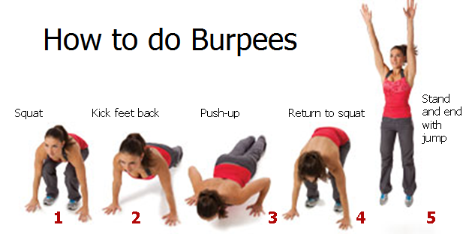
- Children practice completing burpees. Teacher models activity:

- Physical activity can be changed depending on class abilities, time and physical exercise can also be changed to record higher or lower tally results. Other physical activities that could be used include: long jumps between 2 points; star jumps; and sprints between points.

- Split children into groups and ensure each child is aware of role, one person at a time to complete burpees, one person to count number of burpees and one person to use the timer. The remainder of the children can count number of burpees out loud.

- Carry out activity

- Once all children have completed activity and tally chart is complete, children use the information to complete a bar chart to display number of burpees completed by each team member within the group (see resources for bar chart and tally chart)

- Once charts are complete each team can calculate the total number of burpees competed by each team. Results are then shared with the other teams and a winning team is announced.

To provide a hook, each group can represent a single country from the commonwealth games. Children can be provided with flags and stickers to show which country they represent. This will help to add a competitive element to the activity and can lead into official medal ceremonies for winning teams.

Curriculum links:
Pupils should be taught to:
- interpret and present data using bar charts, pictograms and tables
solve one-step and two-step questions [for example, ‘How many more?’ and ‘How many fewer?’] using information presented in scaled bar charts and pictograms and tables.

Statistics – Representations = Interpret and present data using bar charts – Year 2
Statistics – Representations = Interpret and present data using bar charts – Year 3
Statistics – Problem Solving = Solve comparison, sum and difference problems using information presented in bar charts – Year 4

Resources:
Activity 1 – ‘The Hotel Organiser’
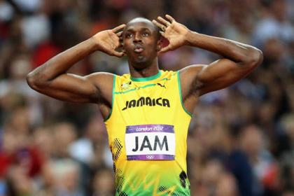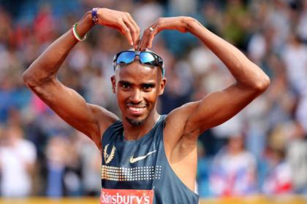
Usain Bolt Mo Farah
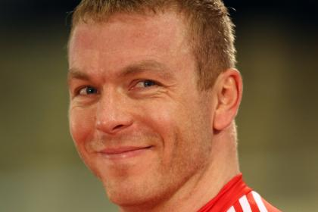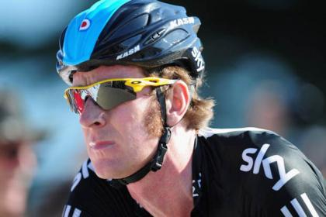
Chris Hoy Bradley Wiggins
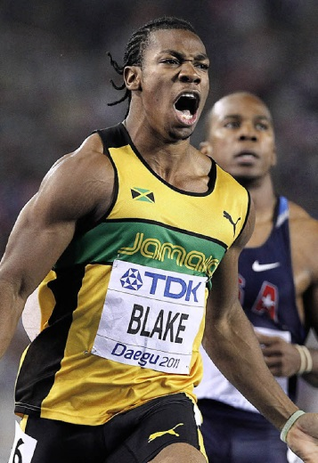
Rebecca Addlington Jennifer Ennis Johann Blake

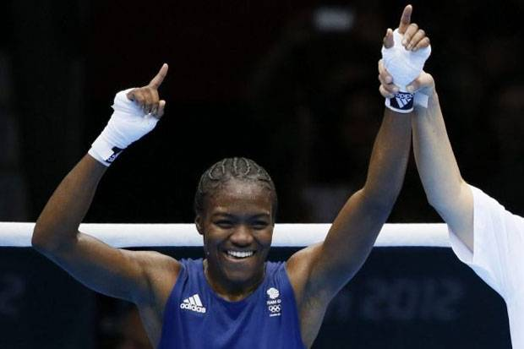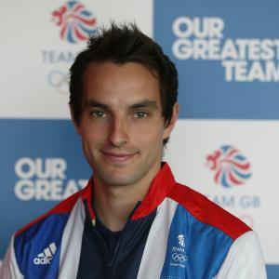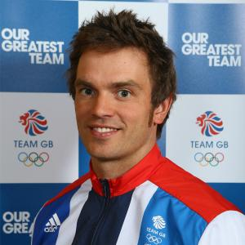
Nicola Adams Nick Caitlin Tim Baillie
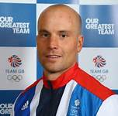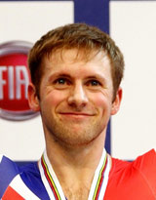
Richard Hounslow Lizzie Armistead Jason Kenny
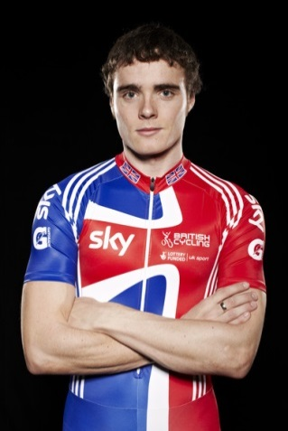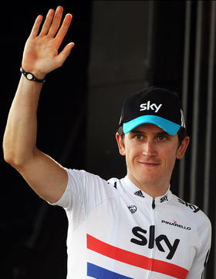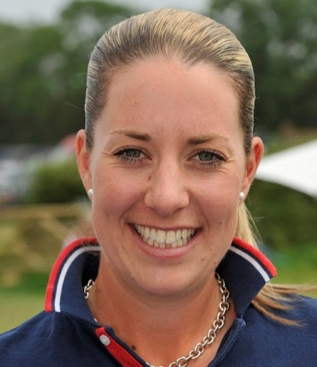
Steven Burke Geriant Thomas Charlotte Dugardin
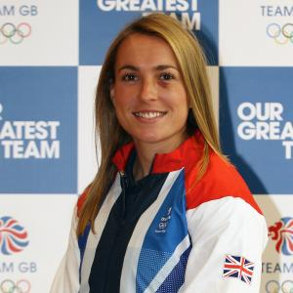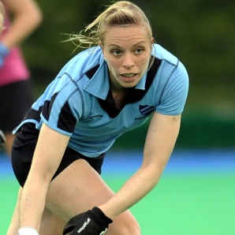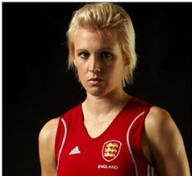
Laura Bartlett Kerry Thelet Alex Danson
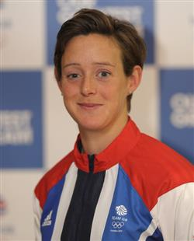

Activity 1 - Script

All 8 of these people need to be in rooms:
They need to be in 2 rooms, which 2 rooms can you put them in? All of the beds need to be filled In each of the rooms - we don't like spare beds!
Kelly Holmes will only share with 1 other person.
Kelly Holmes will also only share with a girl.
Greg Rutherford wants to sleep in a room with twice as many people as Kelly Holmes.
Christa Cullen wants to sleep in a room with 1/4 of the beds in the hotel.
Peter Kennaugh wants to sleep in a room with a prime number of beds, but he is scared of heights!
Victoria Pendleton wants to sleep in a room with a square number of beds.
Andy Murray snores very loudly, so Christine Ohoruogo wants to sleep 2 floors away from him.
Ashleigh Ball wants to sleep in a room with a quarter of 12 beds in it, as that is her lucky number.

The coaches have said that the athletes are being silly and they are to share in rooms of just boys and girls.

Is it or is it not possible to have rooms that are all girls and all boys?

Answers for challenge 1 of Hotel Activity
(note the position of the bedrooms/ which floor)
Christine Oghuruogo, Beth Tweddle, Ashleigh Ball
Robert Grabarz, Christa Cullen, Amir Khan, Philip Hindes, Peter Kennaugh | Victoria Pendleton, Chris Froome, Laura Bechtolshelmer, Greg Rutherford
Ed Clancy, Tom Daley, Andy Murray, David Florence, Anthony Ogogo, Luke Campbell | Denise Lewis, Kelly Holmes

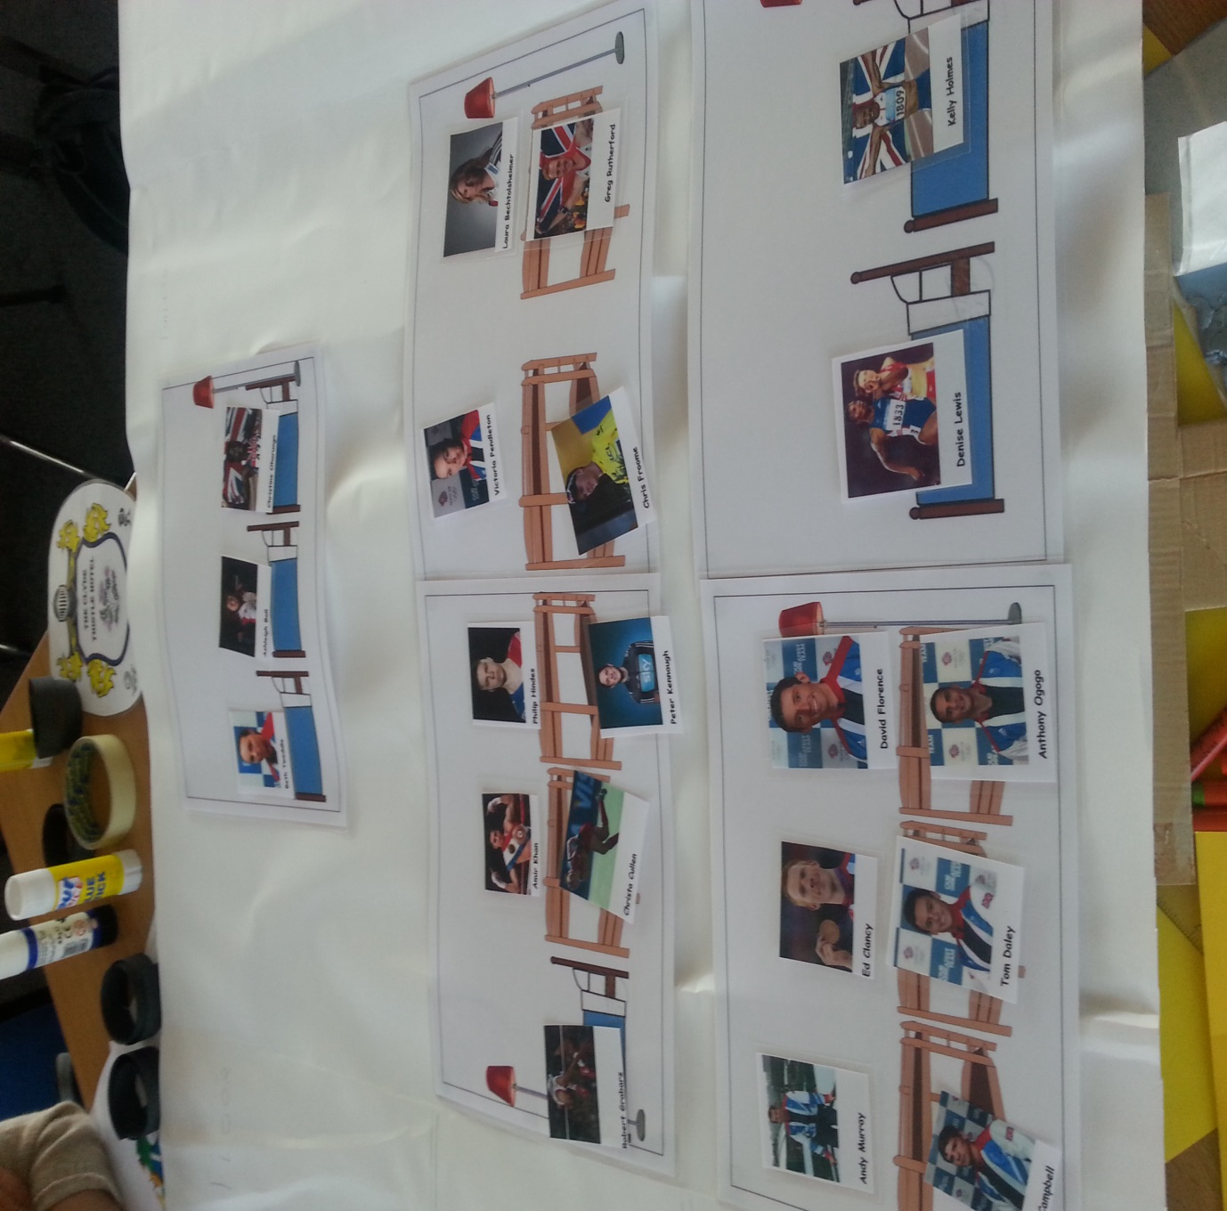

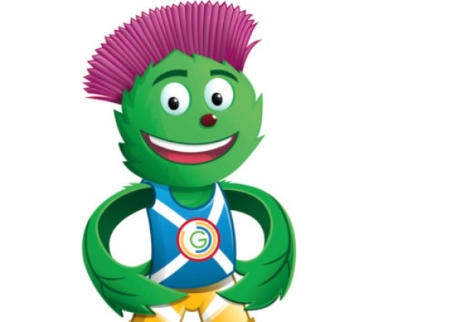
Hi, I’m Clyde. I am looking for a team of expert accommodation managers to organise the GB team sleeping arrangements for the games. The team who wins will be the one who works together, finds the quickest and easiest way of sorting the athletes, and find the best system. So show me your best maths skills and it might be you!!
Hi, I’m Clyde. I am looking for a team of expert accommodation managers to organise the GB team sleeping arrangements for the games. The team who wins will be the one who works together, finds the quickest and easiest way of sorting the athletes, and find the best system. So show me your best maths skills and it might be you!
I’m Clyde. I am looking for a team of expert accommodation managers to organise the GB team sleeping arrangements for the games. The team who wins will be the one who works together, finds the quickest and easiest way of sorting the athletes, and find the best system. So show me your best maths skills and it might be you!

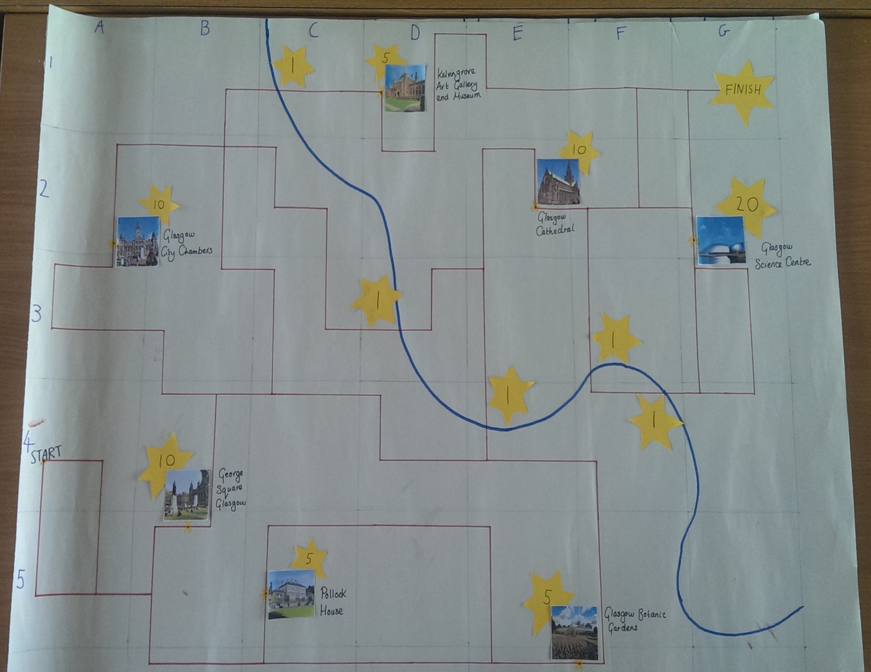
Activity 2 – ‘Marathon Map’

Activity 3 – ‘Burpees’

