Commonwealth Games Theme Week Manchester University 2014 Teacher Resource Pack - Humanities
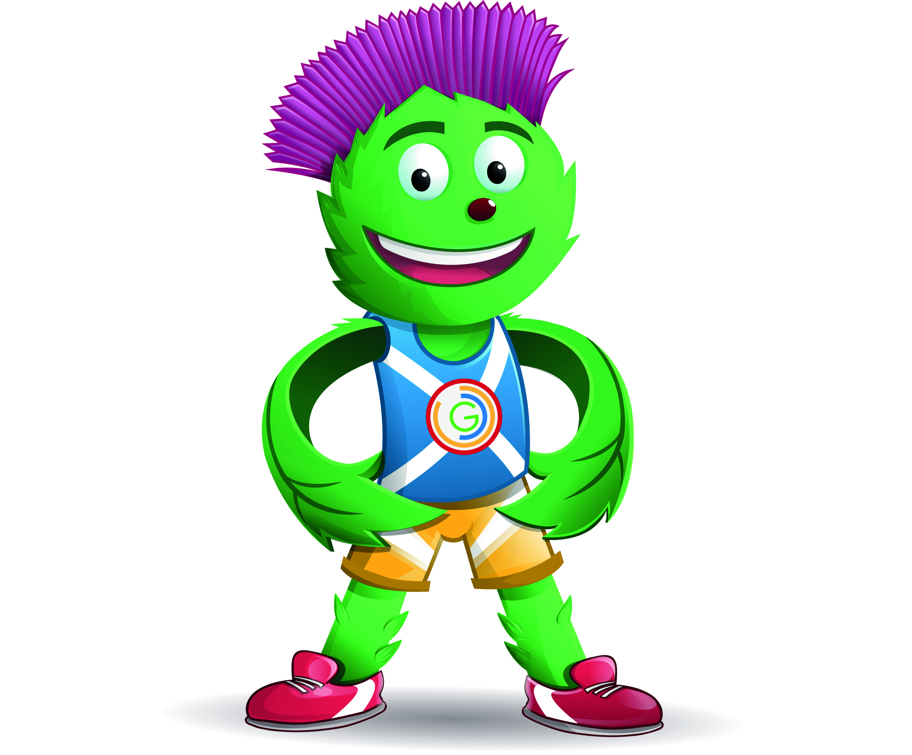
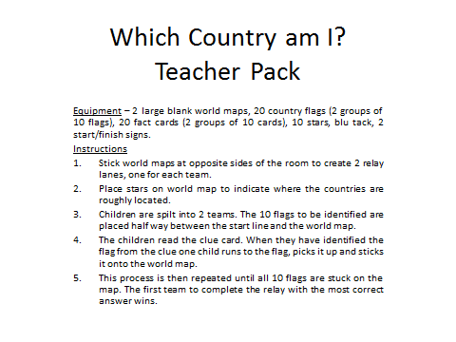
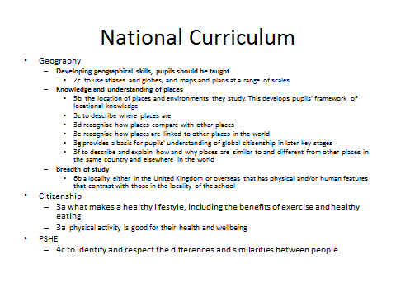
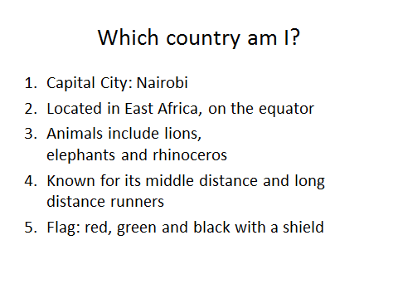
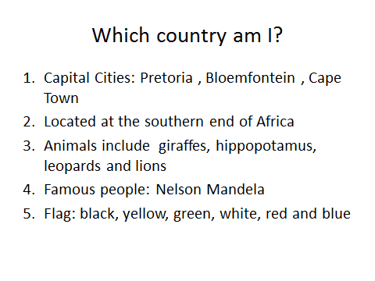
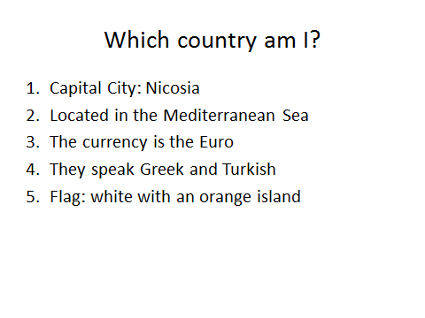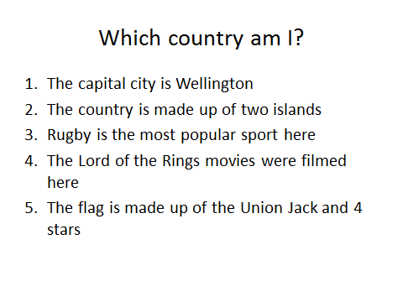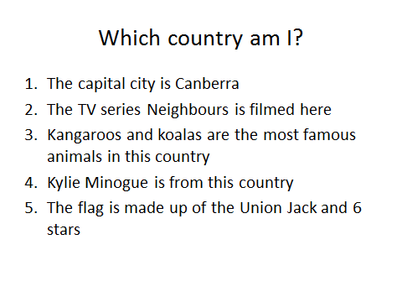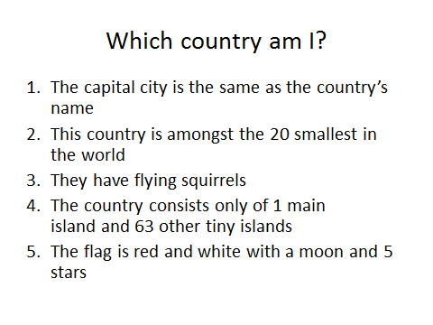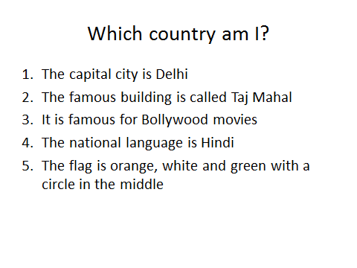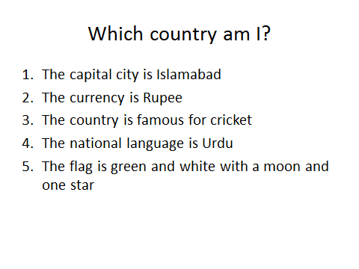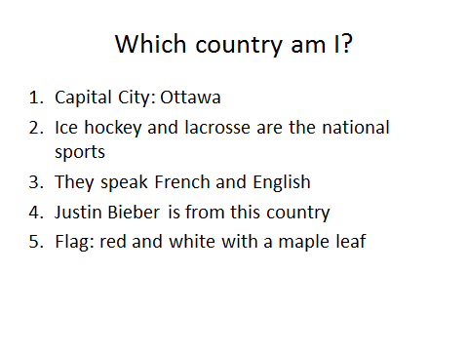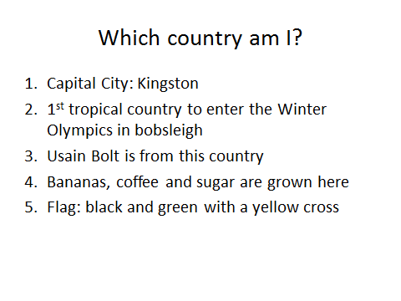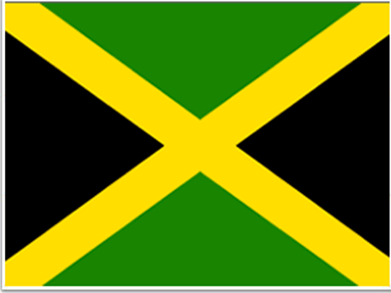
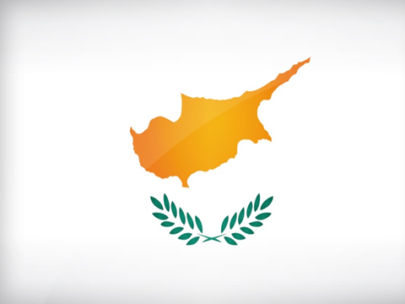
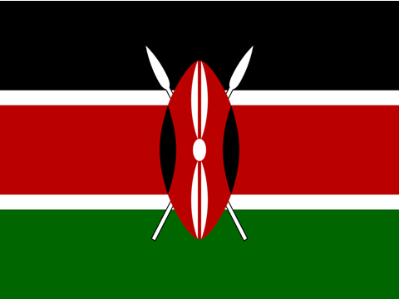
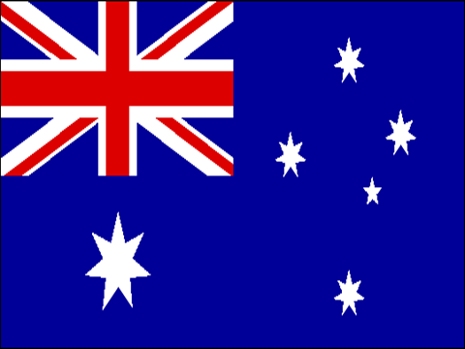
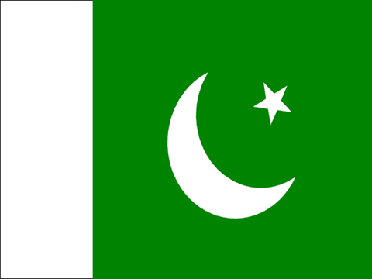
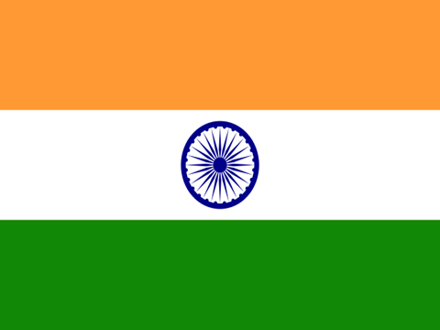
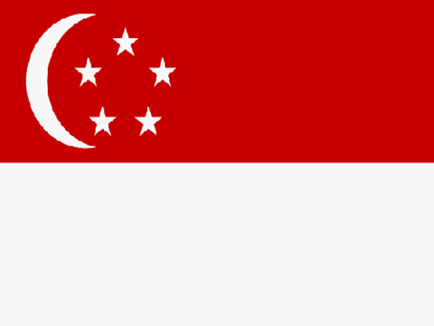
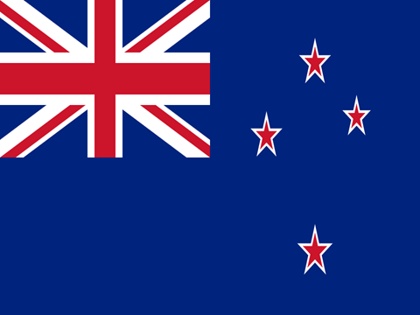

Commonwealth Games Quiz
Instructions
Group of 10 Children
Read statements aloud to the children and ask if they think this is true or false? Explain and model to the children that they have to run to the red card for “false” and green card for “true” in a 'corners' style activity.
Give 5 seconds thinking and discussion time and then do a 5 second count down in which they have to make their decision.
Reveal whether it's true or false and give a brief explanation where necessary.
Back to the middle for the next statement. Repeat.
Resources:
Green card- True
Red Card- False
National Curriculum
- Chronological understanding
  - 1a place events, people and changes into correct periods of time
- Knowledge and understanding of events, people and changes in the past
  - 2b the social, cultural, religious and ethnic diversity of the societies studied, in Britain and the wider world
- Chronological understanding
  - recall, select and organise historical information
  - use dates and historical vocabulary to describe the periods studied

Quiz Questions
- The Commonwealth games were originally known as the British empire games T

- The Commonwealth games are always held in the United Kingdom F

- The Commonwealth games are to be held in Scotland this year? T

- Manchester city stadium was used as the stadium for the commonwealth games in 2002 T

- The mascot for the Commonwealth games is a koala bear F It is a thistle

- Netball is played in the common wealth games but not in the Olympic games T

- Shooting is not an event in the commonwealth games F It is an event in the games

- The commonwealth games are held every four years T

- The commonwealth games is always the same year as the world cup T

- Chelsie takes part in the wrestling event in the commonwealth games F

- There are 30 countries in the commonwealth games F there are 53 countries

- The first commonwealth games took place in Canada in 1930 T

- There are 17 sports in the commonwealth games T

- Gambia left the Commonwealth games in 2013 T- no reason was provided

- David Beckham is head of the commonwealth F it is the Queen

- America is in the commonwealth games F

- Only 6 of the teams have attended every single commonwealth games T Australia, Canada, England, New Zealand, Scotland and Wales

- 11 nations participated in the first commonwealth games? T

- The games continued in 1942 and 1946 during the war? F

Music and Dance
Information about the song
"Chaiyya Chaiyya” is an Indian song from the 1998 Hindi film ‘Dil Se’ which was directed by Mani Ratnam. The literal meaning of the song title is ‘Keep walking in the shade of love.’
The song was composed by A.R. Rahman, a very famous composer in India and sung by Sukhwinder Singh and Sapna Awasthi. It quickly became popular upon release and its music video gained the same status, partly because it was filmed on a moving train.
In 2002, ‏the BBC World Service conducted an international poll to choose the ten most popular songs of all time. Around 7000 songs were selected from all over the world. According to the BBC, people from 155 countries voted "Chaiyya Chaiyya" ninth in the top 10 songs.

"Chaiyya Chaiyya" reached the top of the charts in India and became popular in the United Kingdom.
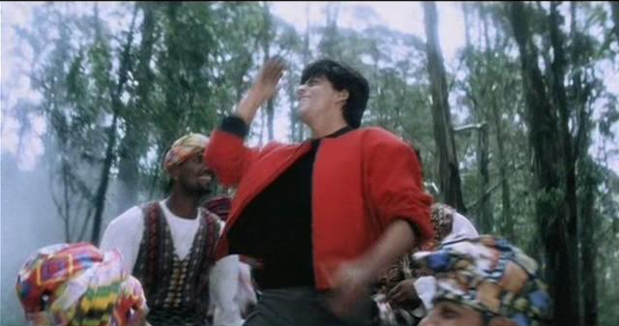

History of Indian Dancing
India's contemporary classical dances trace their origin far back in Indian history. Dance like any other aspect of Indian culture and tradition has developed over thousands of years. It is a very influential art form, for sculptures and pieces of literature from the past all depict some form of dance. Classical Indian dances today trace their roots to a book called the Natyasastra which forms the basis of all the performing arts today.
The first concrete evidence of dance in India can be traced back to the period of the Indus Valley Civilization. However, Indian dancing almost died out during the British rule, but with a tradition of over 5000 years the dance could not be erased forever.
At present, almost all Bollywood films have lots of Indian dances within the songs of the film. Bollywood films have become a worldwide sensation, with almost everyone having seen at least one film.
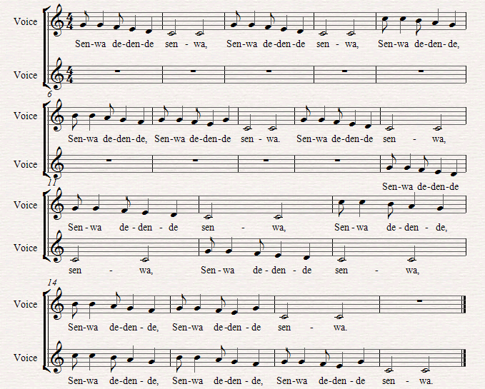
Music and Dance - Senwa Dedende

Senwa Dedende is an African song from Ghana and it is about a mother calling to her children.
Tell them the words and ask them to call to each other saying them.
Teach them the melody line by line and then sing it through a couple of times until they feel confident.
Split the group in half and sing it in a round over and over again until you want to stop. If this works well, more groups can be added.
Introduce percussion such as clapping and body percussion (or drums if available) and give to the children who feel reluctant to join in with the singing.
Ask a child to lead each group in a run through and put their hands high if they want their group to sing louder or lower the hands if they want them to sing quietly.
Extension
Extend by having more groups in the round, changing the tempo and dynamics. They could also have an instrumental section that they could go away and compose in small groups.
You could also teach them an African dance which could be included whilst singing the song.
The National Curriculum

Key Stage 1

- 1a use their voices expressively by singing songs and speaking chants and rhymes.

- 1c rehearse and perform with others.

- 4a to listen with concentration and to internalise and recall sounds with increasing aural memory.

- 5c working on their own, in groups of different sizes and as a class.

Key Stage 2

- 1a sing songs, in unison and two parts, with clear diction, control of pitch, a sense of phrase and musical expression.

- 1c practise, rehearse and present performances with an awareness of the audience.

- 5c working on their own, in groups of different sizes and as a class.

Parachute Game
Allocate countries to the children: India, Canada, Australia, Cyprus and Jamaica.
- Begin by going around the countries, getting them to swap places.
- If your country begins with a…run!
- If your country is cold run.
- If your flag has a Union Jack in it run!
- If your country has green in the flag, swap places.
- If your country does not speak English as its native language, run!
- If your country plays a lot of ice hockey, run!
- If your country has a lot of kangaroos, swap places.
- If your country uses the Euro, swap places.
- Can the children think of any questions for everyone else?
- Commonwealth!! Everybody go.

