Computing Activities

Note: these activities are planned to take place over 10 minutes as tasters, but could easily be expanded to last for a full lesson or series of lessons.

Group of 10 children will be divided into 2 groups of 5 and will complete each activity for 10 minutes before swapping.

Activity 1: Touchcast and Greenscreen

Learning objective: To create a short greenscreen presentation based on the theme of the Commonwealth Games.

Context: Commonwealth games. Athlete has just competed in a race and is being interviewed either trackside or in a studio afterwards.

Curriculum reference:
Key stage 2:
- select, use and combine a variety of software (including internet services) on a range of digital devices to design and create a range of programs, systems and content that accomplish given goals, including collecting, analysing, evaluating and presenting data and information

Resources: Greenscreen, props (costumes, microphone), 4 x iPads (one for autocue, one for filming, 2 for backup activities), scripts loaded onto autocue, backgrounds loaded onto filming iPads.

Backgrounds used:
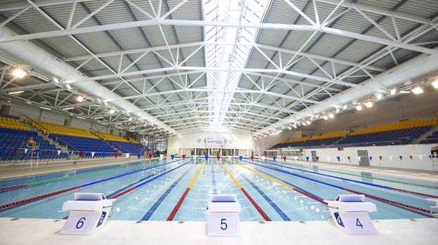
Swimming Pool Background

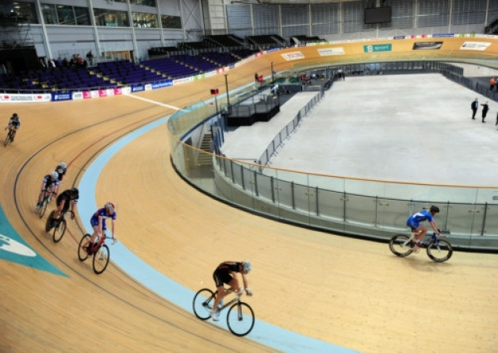
Cycling Background
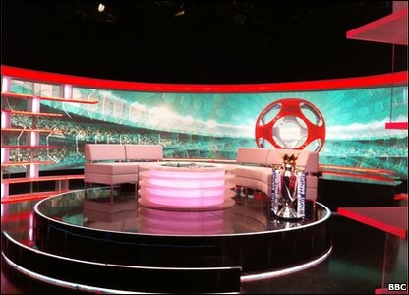
Studio Background
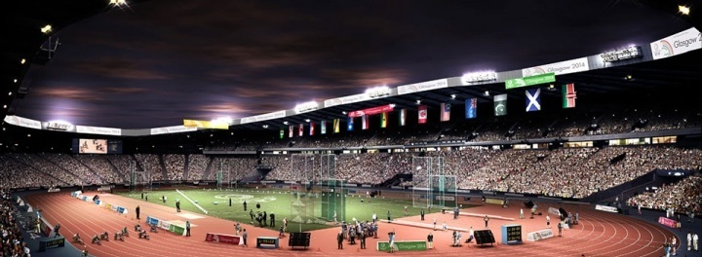
Stadium Background

Script for Interview:

Interviewer: Congratulations! That was an intense race! How are you feeling?

Athlete: (improvise response)

Interviewer: How long did it take you to prepare for this event?

Athlete: (improvise response)

Interviewer: And what do you do to prepare yourself for a big event like this?

Athlete: (improvise response)

Interviewer: So what is next for you?

Athlete: (improvise response)

Activity description:

Children will be required to select a background and props in order to film a short greenscreen “trackside” or “studio” interview. Scripts involve interview questions; athlete responses will be improvised. Children will read the questions from the autocue app on an iPad. An iPad will be used to film the interviews and display them on the screen instantly for children to see.

Introduction to activity - show children the greenscreen and a WAGOLL - 2 minutes
Splitting group into 2 groups - 1 minute
1st group choosing their backgrounds, props and filming - 3 minutes
2nd group choosing their backgrounds, props and filming - 3 minutes

In a classroom scenario, children should be asked to devise their own questions and load this text in to the autocue themselves.

Activity 2: Beebot Challenge

Learning objective: To use logical reasoning to create an algorithm and program it into a bee-bot.

Context: Commonwealth games opening ceremony. Children will be challenged to “race to Glasgow” from different places on a bee-bot world map. Two teams will start from different places and whoever gets to the opening ceremony first will win a “Gold medal” certificate.

Extension activity: children will be required to again “race to Glasgow” but this time will be asked to pick up athletes from different countries on the way.

Curriculum reference:
Key stage 2
Pupils should be taught to:
- design, write and debug programs that accomplish specific goals, including controlling or simulating physical systems; solve problems by decomposing them into smaller parts
- use sequence, selection, and repetition in programs; work with variables and various forms of input and output
- use logical reasoning to explain how some simple algorithms work and to detect and correct errors in algorithms and programs

Cross curriculum links: mathematics (logical reasoning and problem-solving) and geography (knowledge of locations, use of maps, use of grid references).

Resources: 2 x bee-bots, world bee-bot map, worksheets, pens, flag to mark Glasgow, certificates.

Activity description:
- Introduction to activity and quick demo of using bee-bots: 2 minutes
- Split group into 2 teams - one 2 and one 3 and assign roles: scribe, programmer: 1 minute.
- Race to Glasgow: one team from Argentina (K5) and one from Malaysia (E7). Quickest algorithm from both places = 1 >, 4^, 1>, 2^. 5-7 minutes.
- Extension activity (optional): Race to Glasgow, picking up athletes from Cuba and Botswana. Quickest algorithm from both places = 1^, 1>, 3^, 1^, 1>, 3^

The Beebot handout is below:
