Art & Design

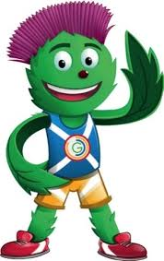

Pupil Task: To produce a large artistic display for The Great Hall, Sackville Street, that represents the Commonwealth Games.

National Curriculum Reference (176 Art/ 180 Design)

- Become proficient in drawing, painting, sculpture or other art, craft and design techniques.

- KS2: To improve their mastery of art and design techniques, including drawing, painting and sculpture with a range of material.

- All pupils will be provided with a flag template from one of 54 countries from the Commonwealth.
- Given twenty minutes, they are expected to fill the template with a variety of different materials, including pipe cleaners, crepe paper and fabric.
- At the end of the task, pupils will be encouraged to contribute their work to a larger collaborative project, in which all countries of the Commonwealth will come together. This large, unique flag will be representative of what the games are about.

Since this Art & Design task focuses on the flags of different countries, it has cross-curricular links with Geography. It will enable pupils to develop some contextual knowledge about the diversity evident at events such as the Commonwealth games.

